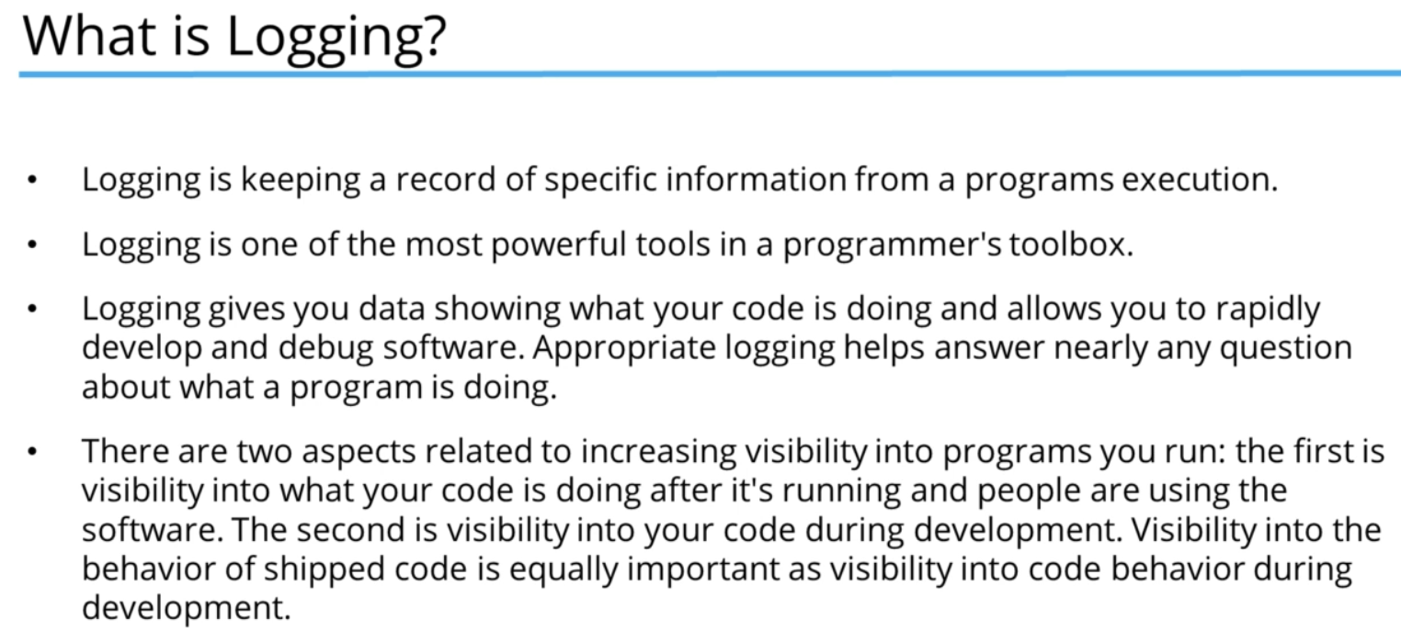

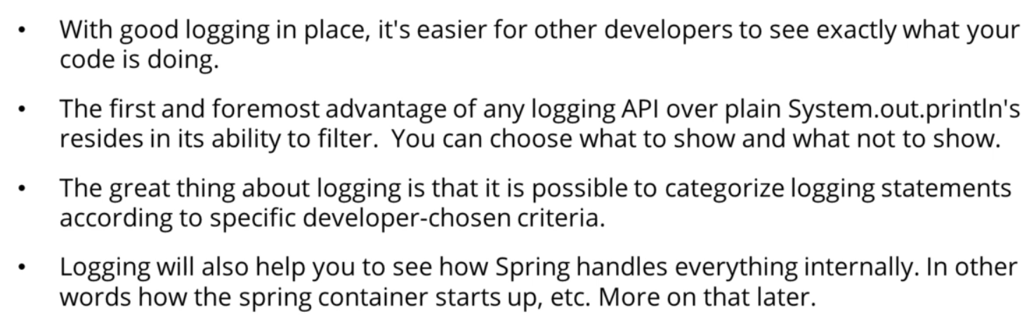

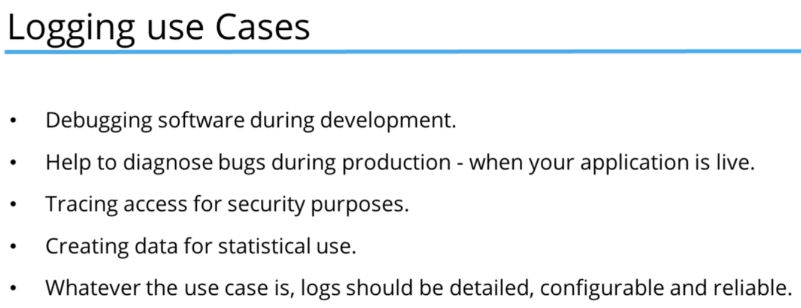

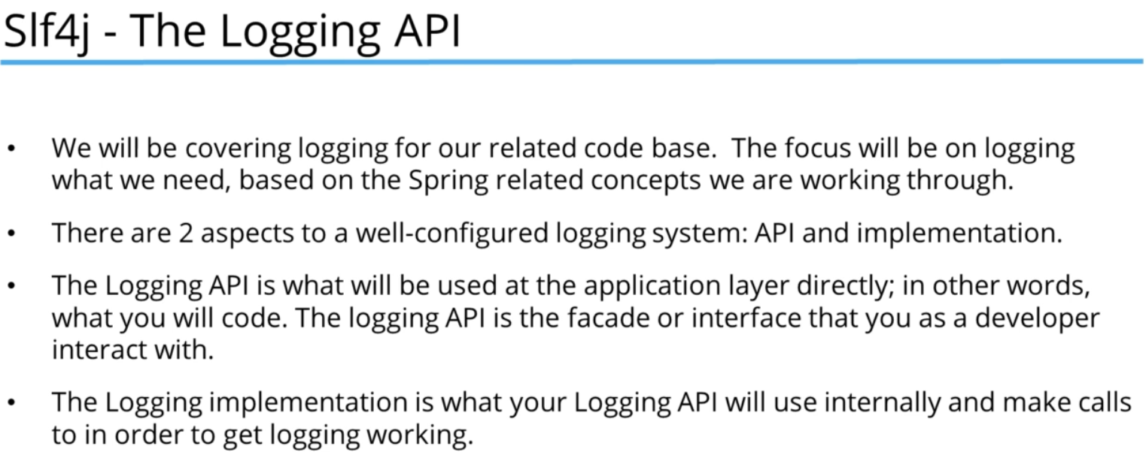

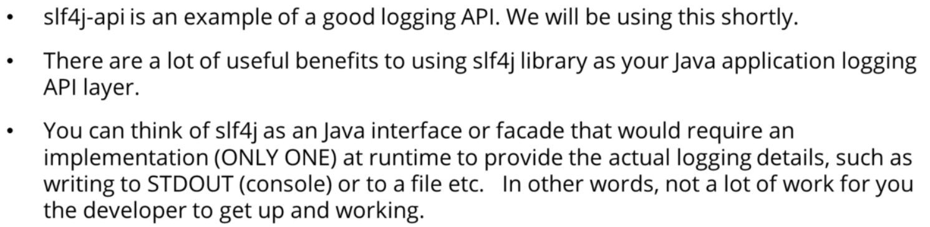

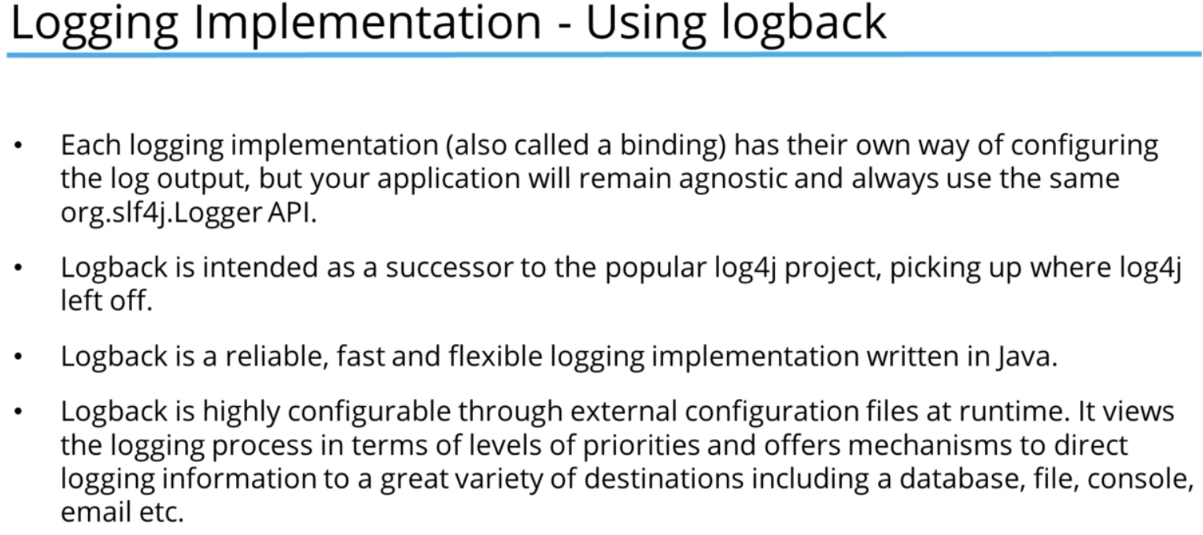

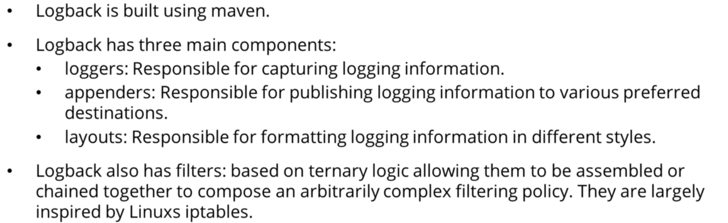

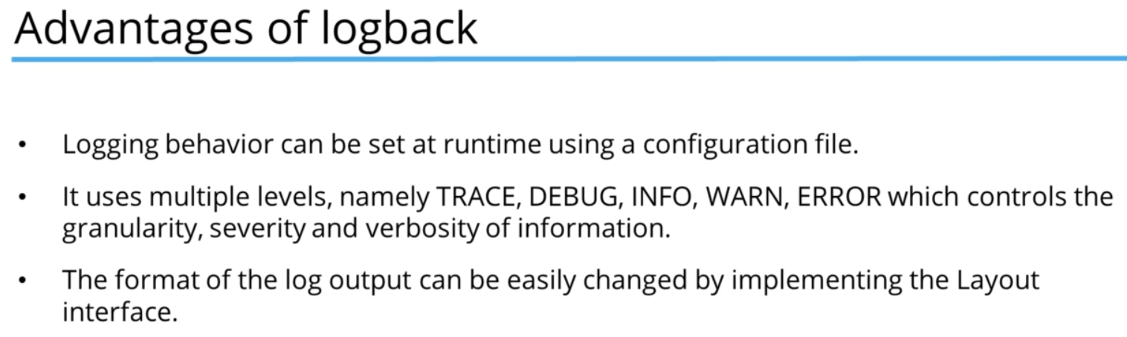

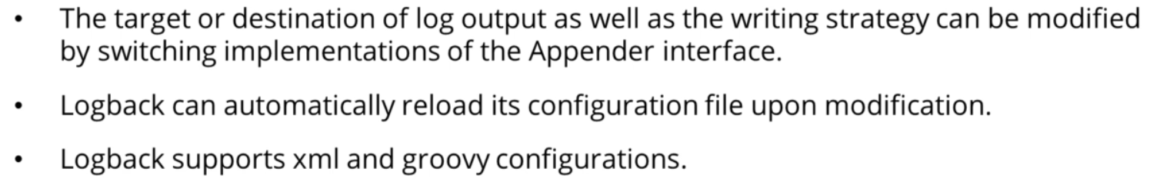

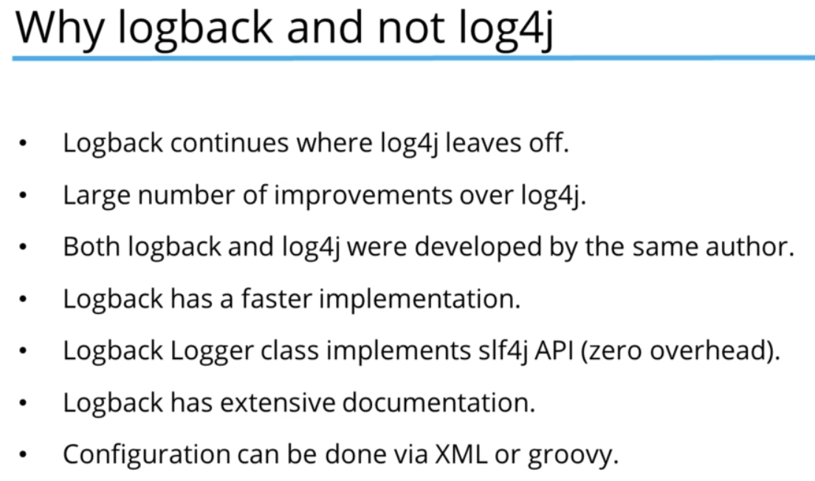

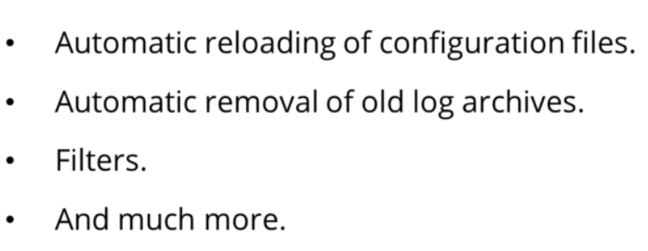

To use logback, we need to add the dependency in the dependencies in the POM.xml file. We can find the code from the MavenReposatory site.

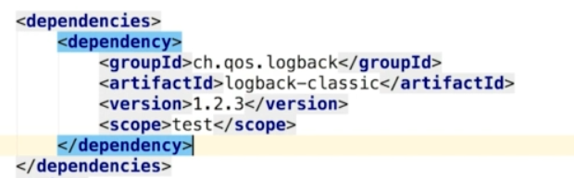

One thing to notice here, is the scope. Here its scoped to test. So, this logging won’t work on our source files on main package classes. We can simply remove the scope in case we want to work on main class logging.



Logger Factory is a utility class that will produce the logger using the get logger method. It can either take a string or class.



We can then use this logger variable to log stuff.



